IBM ATTRITION ANALYSIS
INVESTIGATING REASONS,
FORCASTING, AND
POSSIBLE RETENTION STRATEGIES

Executive Summary
IBM is a global technology corporation, aiming to research, develop products, and provide consultancy services leveraging business data, information technology, cybersecurity, and the ecosystem. As a human capital-intensive firm, IBM must understand and minimize the external voluntary attrition to ensure workforce stability and operational effectiveness.
This report studies the attrition of 1,470 employees to:
- identify key drivers,
- estimate next year’s risk, and
- suggest actionable strategies.
The report suggests a Simple Additive Weighting (SAW) model to evaluate employee significance, highlight viable groups, and identify internal alternatives when needed.
Data visualisation is conducted on SAS® VIYA® for Learners and MS Excel, while R Studio is used for predictive modelling with Logistic Regression (LR), k-Nearest Neighbour (KNN), Extreme Gradient Boosting (XGB), and other analyses. Later, the predictive model is used to prescribe specific retention solutions.
In the long term, we recommend developing an Attrition Risk Dashboard to monitor and forecast attrition trends among key employee groups.
This report acknowledges limitations of a small sample size and restricted dataset. Key recommendations include expanding data collection, developing a data dictionary, and improving the predictive model.
Ethical considerations under UK GDPR and DPA underscore the importance of transparency, consent, and stakeholder collaboration. Future analyses should prioritize responsible data practices and align workforce planning with organisational values through cross-functional collaboration.

Table of Contents

Executive Summary 2
Table of Contents 3
1. Human Capital 4
1.1 Sample overview 4
1.2 Attrition 6
2. Key Employees 8
3. What influences the attrition rate 9
3.1 Methods 9
3.2 Results 9
4. Next year predictions 11
4.1 Prediction 11
4.2 Retention 12
5. Attrition Risk Dashboard 14
6. Limitations and Suggestions 16
7. Ethical considerations 17
Reference 18
Appendices 20
Appendix A: 20
Appendix B: 23
Appendix C: 24

1. Human Capital
Human capital plays a pivotal role in IBM’s operation, as the corporation requires its workforce to engage closely with clients while also possessing strong technical expertise. IBM places high value on problem-solving abilities, management competencies, and consultancy experiences. Employees are also encouraged to contribute to the corporation’s inclusive culture and benefit from a prominent level of internal mobility.
Voluntary attrition is when an employee chooses to leave the business, which is different from natural (retirements), internal (movement within the organization), and involuntary (lay-offs) attrition. IBM, as a human capital-intensive organization (Loufrani-Fedida 2019), should prioritize the strategic importance of retaining talent and is therefore focused on understanding and reducing external voluntary attrition.

1.1 Sample overview
The given dataset of 1,470 non-duplicate employees contains 35 fulfilled variables. Besides the original variables, we create four new categorical variables based on our assumptions:
Table 1: New variables
Assumption | Variables
People intend to retire from the minimum age to receive a pension, which in this case is 50 years old (IBM Pension Plan) | RetirementRisk
People who are new to employment are more likely to leave their job (Park et al. 2024) | Seniority
As IBM values technical skills, employees’ skills from education must better relate to their role | QualificationMatch
As IBM values technical skills, employees’ skill level must better align with their job level | Level Match

In alignment with IBM’s expectations and support for its employees, we categorize the variables into three groups to examine their influence on attrition:
- Demographics
- Satisfaction & Engagement
- Job Conditions & Performance
A full description of each variable is provided in Appendix A.

 | 16.1% Attrition rate |  | 4.7% High Retirement Risk  7.1% Low Retirement Risk

The sample shows an attrition rate of 16.1%, which is significantly lower than the UK average of 34.0% and the 35.2% rate for the Information and Communication industry (CIDP 2024). Approximately 12% of the sample is over the age of 50, while 4.7% identified as having a high retirement risk.
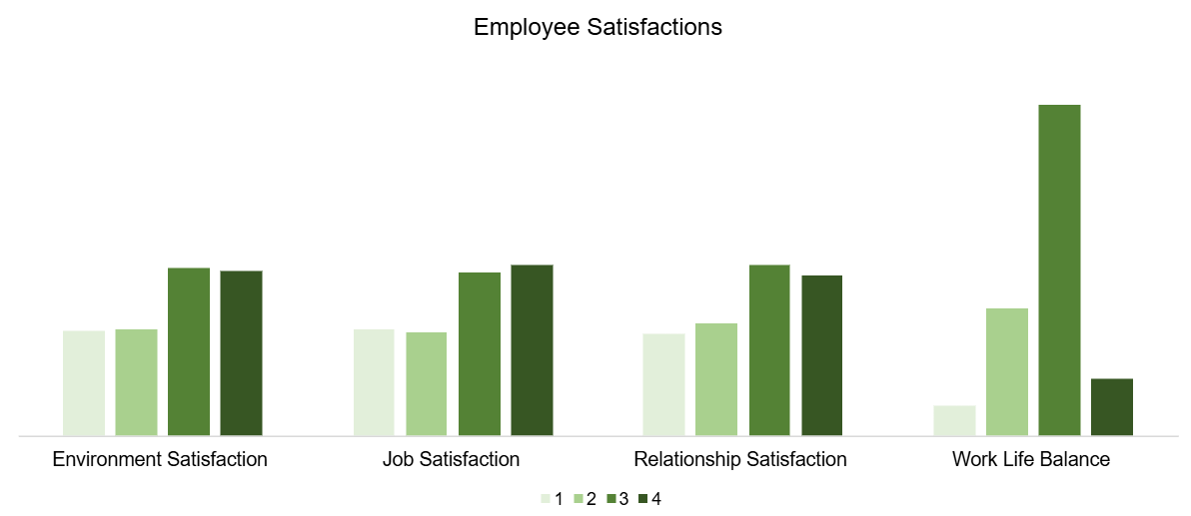
Figure 1: Satisfaction frequency
Most employees report moderately high satisfaction levels (see Figure 1). Specifically, 30% score 3 and another 30 % score 4 for Environment, Job, and Relationship Satisfaction, while 60% score 4 for Work Life Balance.
Figure 2 illustrates the composition of job roles by seniority. Manager, Director, and Executive roles are primarily held by senior and mid-level staff, with few to no associates. Healthcare Representatives show a similar composition, likely due to the technical demands of the role. Other job roles are predominantly mid-level, except for Sales Representatives, which have the fewest seniors and mid-levels. Only Laboratory Technicians, Research Scientists, and Sales Representatives include newcomers. Newcomers and Juniors make up nearly 69% of Sales Representatives.
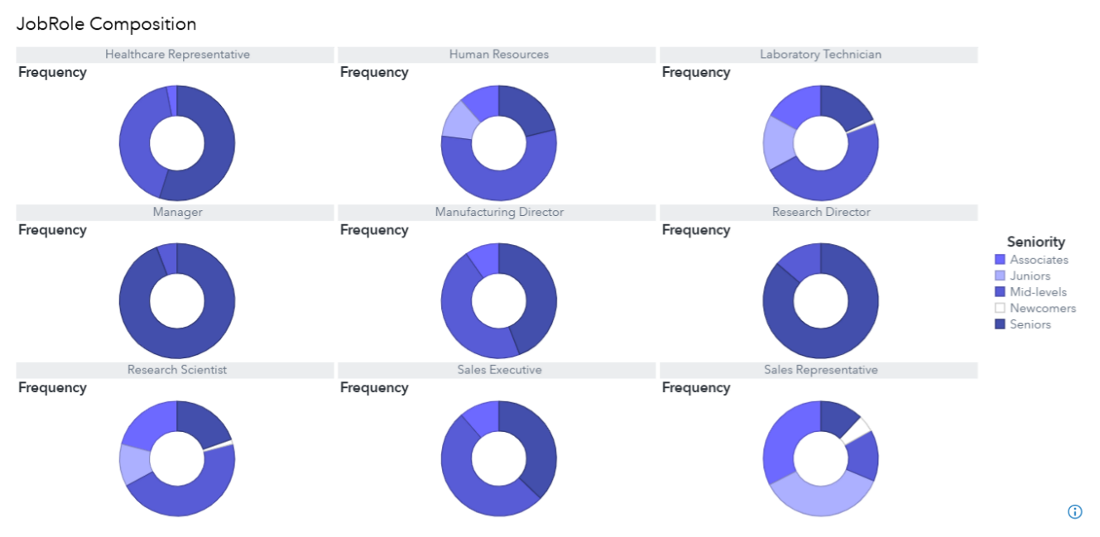
Figure 2: Job roles composition of Seniority

1.2 Attrition
According to Figure 3, positions within the Sales Department exhibit a higher attrition rate compared to similar roles in other departments. Notably, Sales Representative has the highest percentage of employee departures. In contrast, roles such as Healthcare Representative, Manufacturing Director, and Research Director have exceptionally low attrition rates.
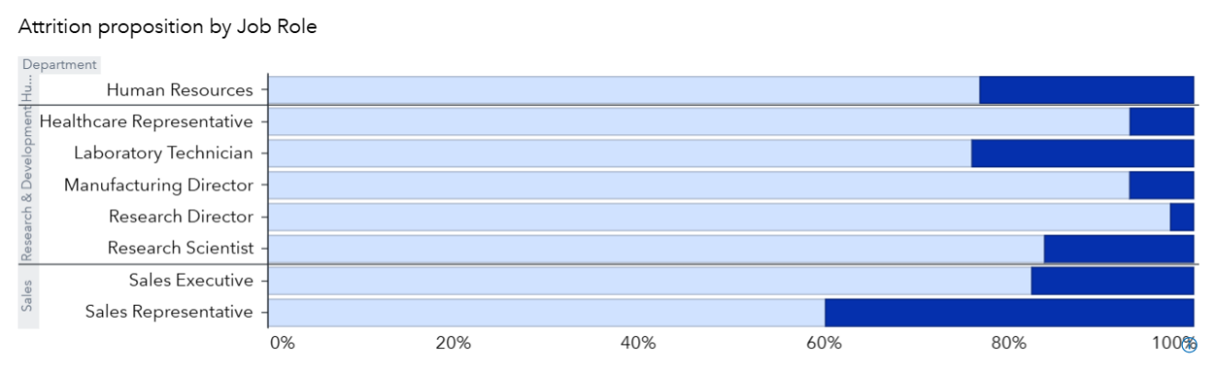
Figure 3: Attrition proposition by Job roles
The boxplots in Figure 4 illustrate the range, interquartile range, and median values of Satisfaction & Engagement variables. The interquartile ranges for Environment Satisfaction and Job Satisfaction differ between current and terminated employees. Terminated employees also tend to have shorter tenure at the company and with their current manager. These observations suggest that these variables may serve as strong predictors of attrition.
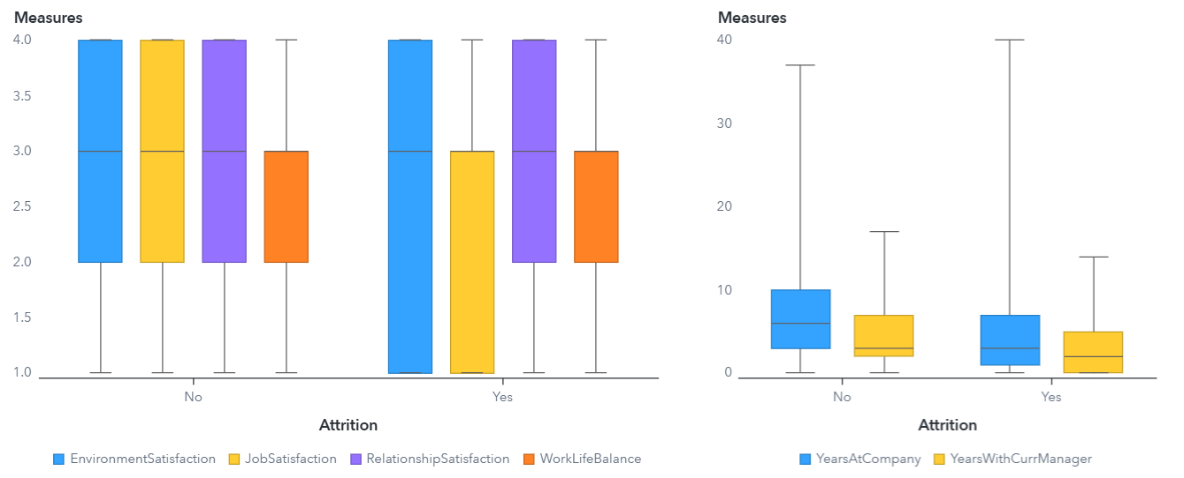
Figure 4: Satisfaction & Engagement Boxplots

2. Key Employees
Identifying key talent within the organization is essential. IBM encourages job movements within the corporation through its Skills-First Talent Strategy, which enables employees to apply for any position if they possess the mandatory skill set. Higher-level roles typically require additional management capabilities and relevant field experience. Only seniors are considered for executive positions, based on specific assessment criteria.
We adopt Simple Additive Weighting (SAW) to rank the employees based on five criteria:
- If the employee currently works as a Director, Executive, or Manager
- How many years of experience do they have in their current role
- How many years have they been working
- Performance rating
- Current job level
Each criterion is graded on a numerical scale (see Appendix B). Here, the criteria are normalized using the sample’s max values of each due to the unknown original scale and are weighted equally. The results, key employee scores, are the total scores of the defined criteria, ranging from 0 to 1. Figure 5 shows an example of a key employee table from the sample.
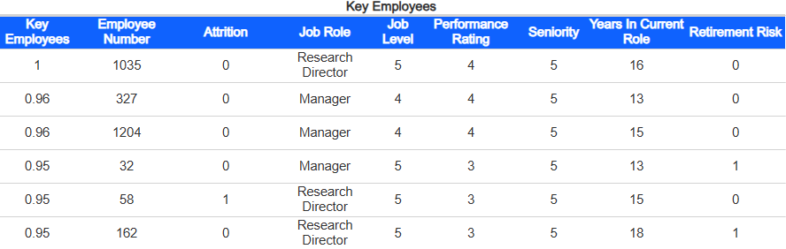
Figure 5: Sample Key Employees Table

3. What influences the attrition rate

3.1 Methods
Logistic Regression (LR) is a widely used classification technique in business research and, more recently, in HRM for various purposes, including employability prediction (Celine et al. 2020; Almajed et al. 2024) and employee turnover analysis (Park et al. 2024; Rombaut & Guerry 2018; Yadav et al. 2018). Moreover, LR is practically well-suited for binary response variables, making it advantageous for attrition prediction.
We apply LR on the three variable groups – Demographics, Satisfaction & Engagement, and Job Conditions & Performance. ANOVA is used to compare the regression models and determine the best-performing one.
Once the optimal model is selected through LR, we further evaluate the predictors using two additional classification techniques: k-Nearest Neighbour (KNN) and Extreme Gradient Boosting (XGB). Confusion matrices, showing correct and incorrect predictions relative to actual observations, are used to calculate the model accuracy and sensitivity. Accuracy refers to the proportion of total correct predictions across the dataset, while sensitivity indicates the proportion of correctly predicted attrition out of all observed attrition. Since the primary goal of this report is to predict employee attrition, particular emphasis is placed on sensitivity.

3.2 Results
Among the variable groups, Job Conditions & Performance model performs the best in predicting employee attrition. The final LR model aligns with initial expectations: Job Role has a significant impact on turnover likelihood. Specifically, the Managers and Research Directors are least likely to depart, while Sales Representatives exhibit the highest risk.
Additional findings show that employees who are highly involved with their jobs, have long tenure in their current positions, hold higher job levels, or receive frequent training are less likely to leave. In contrast, people who work overtime or have not been promoted recently are more prone to attrition.
During the model training and testing process, we identify the decision boundary of 0.50 (see Appendix C, Table 5). Therefore, if the predicted probability of attrition is equal to or greater than 0.50, the employee is classified as at risk of leaving.
The sensitivity levels of all three models – LR, KNN, and XGB – are relatively low. Nevertheless, we continue with the LR model to support the following recommendations, due to its overall interpretability and slightly better performance. Full results and supporting analysis are provided in Appendix C.

4. Next year predictions
Now we have a model for predicting attrition, we expect to use that model to evaluate the current employees (whose attrition is “No” in the sample) for the next year. There are two problems we want to investigate:
- Who will leave their jobs? Do the key players have a high probability of turnover?
- Do we want to keep these employees? How can we do that?

4.1 Prediction
Assuming no changes occur in the coming year, we hold all other variables constant and increment both YearsSinceLastPromotion and YearsInCurrentRole by one. Each employee’s updated data is then processed through the previously defined predictive function. If the result exceeds 0.50, the employee is flagged as at risk of turnover.
We merge the prediction results and predictors into the key employees table as shown in Figure 6. The employee with the highest predicted attrition risk is Employee 746, currently a Sales Executive, who has no retirement risk but has not been promoted for 12 years. Additionally, we anticipate that five Sales Executives may leave next year based on the predictions.
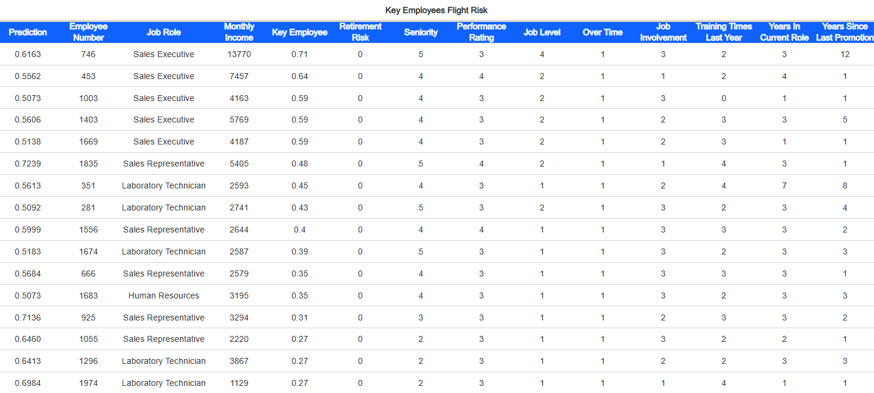
Figure 6: Next year's predicted attrition, sorted by key employee score

4.2 Retention
Given the critical nature of the Sales Executive role, retaining talent in this position is a priority, as replacements are difficult to source. We explore several potential interventions: increasing monthly income, raising job levels, reducing overtime, or providing additional training. The defined predictive function is used to assess the minimum change needed. This is done by incrementally adjusting the selected variable while holding others constant until the probability is lower than 0.50.
As an example, we apply this method to training frequency. Figure 7 illustrates the minimum training sessions required to retain employees, side by side with the original times. For instance, Employee 746 would need four additional trainings to bring their predicted probability of departure below the decision boundary.
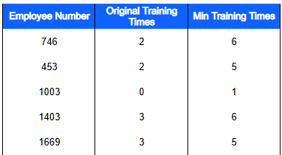
Figure 7: Number of trainings needed to retain high-risk employees
In cases where such interventions are not feasible, internal replacement may be considered. Using the Attrition Risk Dashboard, we can filter senior candidates who have low attrition and retirement risk, a high performance rating, strong job involvement, and a comparable income range (1,200 – 1,400). After shortlisting potential alternatives (see Figure 8), we identify the most suitable match.
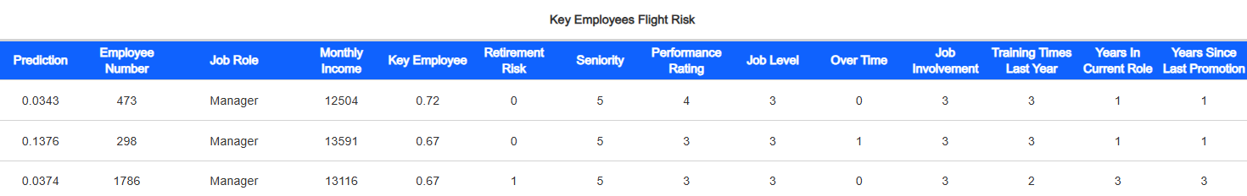
Figure 8: Filtering best alternatives for employee 746's position
In this scenario, Employee 473 emerges as the best internal replacement for Employee 746. Employee 473 is a senior with minimal attrition risk, a top performance rating, high job level, and strong involvement. Notably, this individual also has a higher key employee score than Employee 746, further supporting their suitability for the role.

5. Attrition Risk Dashboard
Eventually, we suggest developing an Attrition Risk Dashboard to track the turnover probability of key employees and recognize the individuals at high risk. The dashboard should have:
[Mandatory] Employee predicted attrition risk, which is the probability calculated from the antecedent predictive function
[Optional] Current attrition patterns
[Optional] Possible retention strategies
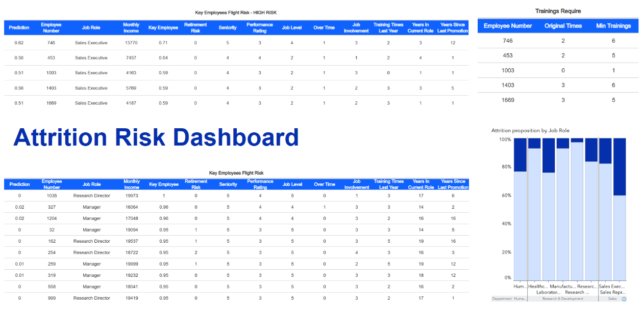
Figure 9: Paradigm of Attrition Risk Dashboard
Figure 9 shows a paradigm of the Attrition Risk Dashboard developed based on this report analysis. The dashboard is organized by key employee score to ensure focused oversight of high-value personnel. Besides the turnover probability, the dashboard also displays the significant variables contributing to the predictions. This transparency enables managers to understand the rationale and make changes where applicable.
The dashboard includes two primary views: an all-employees table and a high-risk table, the latter focusing on the forecasted-to-leave employees. As previously demonstrated, the first one can be used to filter for suitable internal alternatives for those flagged in the latter.
Incorporating attrition trends into the dashboard is also helpful. For instance, Sales Representatives show the highest turnover rate. This role may warrant particular attention from HR managers, and the dashboard enables filtering and sorting to identify individuals most at risk or to estimate the number certain to leave, thus enabling proactive recruitment planning.
Finally, we recommend tracking the effectiveness of retention efforts. This paradigm includes Figure 7, which helps managers determine whether increasing training is a viable option or whether alternative interventions are necessary when the required trainings exceed organizational capacity.

6. Limitations and Suggestions
This report is based on a limited dataset and a relatively small sample size, which may constrain the generalizability and comprehensiveness of the analysis. To strengthen the robustness and reliability of future analyses, we have found several key areas for improvement:
- Develop a data dictionary that includes detailed descriptions of each variable, along with data types and measurement scales. This will improve data transparency and enhance the overall reliability of future findings.
- Expand data collection by incorporating additional variables to enable more targeted and meaningful analysis:
  - Date of most recent data update – to ensure temporal relevance and help track trends over time.
  - Attrition type – to differentiate between voluntary, involuntary, and retirement, offering a more nuanced understanding of employee exits.
- The predictive model provided in this report does not show a significant sensitivity in forecasting attrition. Future analysis is encouraged to continue investigating attrition predictors and refining model performance.
These enhancements will support more informed decision-making and contribute to a deeper understanding of attrition trends across the corporation.

7. Ethical considerations
This analysis raises several important data protection and ethical considerations under the UK General Data Protection Regulation (UK GDPR) and the Data Protection Act 2018 (DPA), related to transparency, accuracy, and privacy.
- Employees must be fully informed about how their data is used, and proper consent should be obtained where necessary, especially when analysing attrition, as we continue to store and use the data of terminated employees.
- Data collection must clearly document data sources, collection dates, and variable definitions.
- The Key Employee metric derived in this report, assuming uniform weights for all variables, may not accurately reflect the relative importance of different performance indicators. Without input from HR and departmental stakeholders, such simplifications risk introducing bias into workforce evaluations.
- It is essential to approach data analysis as a support tool to mitigate unintended bias and build trust in data-driven initiatives rather than a substitute for human judgment. Transparent, cross-functional, and extensive discussions between HR and other departments are necessary to ensure that human capital analysis and planning align with organisational values and strategic goals.

Reference
Almajed, I.H.A., Nassreddine, G. and Younis, J. 2024. New Recruitment Approach Based on Logistic Regression Model. Mesopotamian Journal of Computer Science. [Online]. 2024, pp.15-27. [Accessed 29 March 2025]. Available from: https://doi.org/10.58496/MJCSC/2024/002.
Celine, S., Dominic, M.M. and Devi, M.S. 2020. Logistic regression for employability prediction. International Journal of Innovative Technology and Exploring Engineering. [Online]. 9(3), pp.2471-2478. [Accessed 29 March 2025]. Available from: https://doi.org/10.35940/ijitee.C8170.019320.
CIPD. 2024. Benchmarking employee turnover: What are the latest trends and insights? [Online] [Accessed 29 March 2025]. Available from: https://www.cipd.org/uk/views-and-insights/thought-leadership/cipd-voice/benchmarking-employee-turnover/#:~:text=Turnover%20data,%2Dterm%20sickness%2C%20for%20example.
Loufrani-Fedida, S. 2019. HRM Practices in Human Capital-Intensive Firms: An Empirical Study of IBM Corporation. In: Cézanne, C. and Saglietto, L. ed. Global Perspectives on Human Capital-Intensive Firms. [Online] Hershey: IGI Global, pp. 30-52. [Accessed 29 March 2025]. Available from: https://doi.org/10.4018/978-1-5225-7426-2.ch002.
Park, J., Feng, Y. and Jeong, S.P. 2024. Developing an advanced prediction model for new employee turnover intention utilizing machine learning techniques. Scientific Reports. [Online]. 14(1), p.1221. [Accessed 29 March 2025]. Available from: https://doi.org/10.1038/s41598-023-50593-4.
Rombaut, E. and Guerry, M. 2018. Predicting voluntary turnover through human resources database analysis: MRN. Management Research Review. [Online]. 41(1), pp. 96-112. [Accessed 29 March 2025]. Available from: https://doi.org/10.1108/MRR-04-2017-0098.
Yadav, S., Jain, A. and Singh, D. 2018. Early prediction of employee attrition using data mining techniques. In: Goswami, A. IEEE 8th international advance computing conference (IACC), 14-15 December 2018, India. [Online]. India: IEEE, pp. 349-354. [Date accessed]. Available from: https://doi.org/10.1109/IADCC.2018.8692137.

Appendices

Appendix A:
Table 2: Variables Description
 | Variable | Description
 | Attrition | Yes/No - Whether the employee leaved
Demographics  (5) | Age | Age of the employee
 | Gender | Female/Male
 | Seniority | i = Total working years;  i = 0: Seniority = “Newcomers”,  i = 1: Seniority = “Juniors”,  i = 2: Seniority = “Associates”,  i = 3: Seniority = “Mid-levels”,  ≤ i : Seniority = “Seniors”
 | DistanceFromHome | Distance from home to company
 | RetirementRisk | i = Age;  i < 50: RetirementRisk = 0,  50 ≤ i < 55: RetirementRisk = 1,  55 ≤ i: RetirementRisk = 2
Satisfaction & Engagement  (6) | EnvironmentSatisfaction | Level of contentment with the environment, from 1 to 4
 | JobSatisfaction | Level of contentment with the job, from 1 to 4
 | RelationshipSatisfaction | Level of contentment with existing relationships, from 1 to 4
 | WorkLifeBalance | Harmonious level of work and personal life, from 1 to 4
 | YearsAtCompany | Number of years working at the company
 | YearsWithCurrManager | Number of years working with current manager
Job Conditions & Performances (12) | QualificationMatch | If the education field related to the role (see more below)
 | LevelMatch | If the education level higher (1), equal (0), or lower (-1) than the job level
 | JobLevel | Job level from 1 to 5
 | JobRole | Employee’s position
 | MonthlyIncome | Monthly income
 | OverTime | Yes/No - Whether the employee works overtime
 | JobInvolvement | How employee connects with their work, from 1 to 4
 | PerformanceRating | Evaluating employee’s work
 | PercentSalaryHike | Percent salary hike
 | TrainingTimesLastYear | Training times last year
 | YearsInCurrentRole | Number of years in current role
 | YearsSinceLastPromotion | Number of years since last promotion

Table 3: QualificationMatch
Job Role | Education Field
Human Resources | Human Resources
Laboratory Technician | Technical Degree
Research Director  Research Scientist  Manufacturing Director | Life Sciences  Technical Degree
Sales Representative  Sales Executive | Marketing  Technical Degree
Healthcare Representative | Medical
Manager | All

Appendix B:
Table 4: Key Employee Criteria
Variables | Criteria
1. Position | If the employee currently works as a Director, Executive, or Manager, then Position = 1, otherwise, Position = 0
2. YearsExp | If YearsInCurrentRole ≤ 5, then YearsExp = 0  If 5 < YearsInCurrentRole ≤ 10, then YearsExp = 1  If YearsInCurrentRole > 10, then YearsExp = 2
3. Seniority | Seniority = “Newcomers” = 1  Seniority = “Juniors” = 2  Seniority = “Associates” = 3  Seniority = “Mid-levels” = 4  Seniority = “Seniors” = 5
4. PerformanceRating | Use PerformanceRating scale
5. JobLevel | Use JobLevel scale

Simple Additive Weighting (SAW) model to calculate Key Employee Score:
$$KeyEmployeeScore=\left(\frac{Position}{\max\left(Position\right)}+\frac{YearsExp}{\max\left(YearsExp\right)}+\frac{Seniority}{\max\left(Seniority\right)}+\frac{PerformanceRating}{\max\left(PerformanceRating\right)}+\frac{JobLevel}{\max\left(JobLevel\right)}\right)×0.2$$
where:
$\frac{Position}{\max\left(Position\right)}$ is the normalized value of Position,
$0.2$ is the weight of each criterion, adjusted based on discussions with HR and departmental managers.

Appendix C:
Table 5: ANOVA results
Demographic
 | ANOVA results  Signif. codes: 0 ‘***’ 0.001 ‘**’ 0.01 ‘*’ 0.05 ‘.’ 0.1 ‘ ’ 1 | Better model
1 | Model 1: Remove Gender  Model 2: Original  Resid. Df Resid. Dev Df Deviance Pr(>Chi)  1 1465 1210.2  2 1464 1209.5 1 0.63867 0.4242 | Model 1
Satisfaction and Engagement
 | ANOVA results  Signif. codes: 0 ‘***’ 0.001 ‘**’ 0.01 ‘*’ 0.05 ‘.’ 0.1 ‘ ’ 1 | Better model
1 | Model 1: Remove YearsAtCompany  Model 2: Original  Resid. Df Resid. Dev Df Deviance Pr(>Chi)  1 1464 1216.2  2 1463 1215.7 1 0.53376 0.465 | Model 1
2 | Model 1: Remove YearsAtCompany & RelationshipSatisfaction  Model 2: Remove YearsAtCompany  Resid. Df Resid. Dev Df Deviance Pr(>Chi)  1 1465 1219.3  2 1464 1216.2 1 3.0928 0.07864 . | Model 1
Job Conditions
 | ANOVA results  Signif. codes: 0 ‘***’ 0.001 ‘**’ 0.01 ‘*’ 0.05 ‘.’ 0.1 ‘ ’ 1 | Better model
1 | Model 1: Remove JobRole  Model 2: Original  Resid. Df Resid. Dev Df Deviance Pr(>Chi)  1 1458 1098.9  2 1450 1056.5 8 42.481 1.1e-06 *** | Model 2
2 | Model 1: Remove MonthlyIncome  Model 2: Original  Resid. Df Resid. Dev Df Deviance Pr(>Chi)  1 1451 1056.5  2 1450 1056.5 1 0.030805 0.8607 | Model 1
3 | Model 1: Remove MonthlyIncome & QualificationMatch  Model 2: Remove MonthlyIncome  Resid. Df Resid. Dev Df Deviance Pr(>Chi)  1 1452 1056.7  2 1451 1056.5 1 0.21741 0.641 | Model 1
4 | Model 1: Remove LevelMatch, MonthlyIncome & QualificationMatch  Model 2: Remove MonthlyIncome & QualificationMatch  Resid. Df Resid. Dev Df Deviance Pr(>Chi)  1 1453 1057.0  2 1452 1056.7 1 0.2607 0.6096 | Model 1
5 | Model 1: Remove LevelMatch, PerformanceRating, MonthlyIncome & QualificationMatch  Model 2: Remove LevelMatch, MonthlyIncome & QualificationMatch  Resid. Df Resid. Dev Df Deviance Pr(>Chi)  1 1454 1057.3  2 1453 1057.0 1 0.35273 0.5526 | Model 1
6 | Model 1: Remove LevelMatch, PerformanceRating, PercentSalaryHike, MonthlyIncome & QualificationMatch  Model 2: Remove LevelMatch, PerformanceRating, MonthlyIncome & QualificationMatch  Resid. Df Resid. Dev Df Deviance Pr(>Chi)  1 1455 1057.7  2 1454 1057.3 1 0.43069 0.5116 | Model 1
Compare between three groups
 | ANOVA results  Signif. codes: 0 ‘***’ 0.001 ‘**’ 0.01 ‘*’ 0.05 ‘.’ 0.1 ‘ ’ 1 | Better model
 | Model 1: Satisfaction & Engagement  Model 2: Employee Characteristices  Model 3: Job Conditions  Resid. Df Resid. Dev Df Deviance Pr(>Chi)  1 1465 1219.3  2 1465 1210.2 0 9.102  3 1455 1057.7 10 152.437 < 2.2e-16 *** | Model 3

Table 6: Decision Boundary
Decision Boundary | Accuracy | Sensitivity
0.52 | 0.8605 | 0.1899
0.51 | 0.8605 | 0.2025
0.50 | 0.8612 | 0.2194
0.49 | 0.8605 | 0.2194
0.48 | 0.8605 | 0.2405
Accuracy: proportion of total correct predictions over the whole dataset
Sensitivity: proportion of correct turnover predictions over the observed turnover
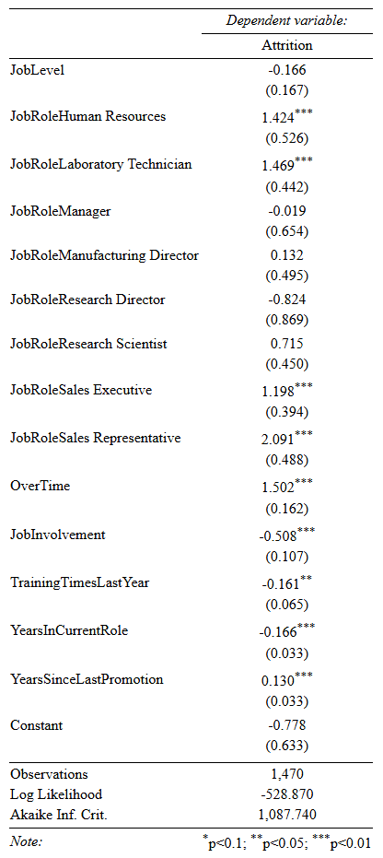
Figure 10: Best logistic regression result
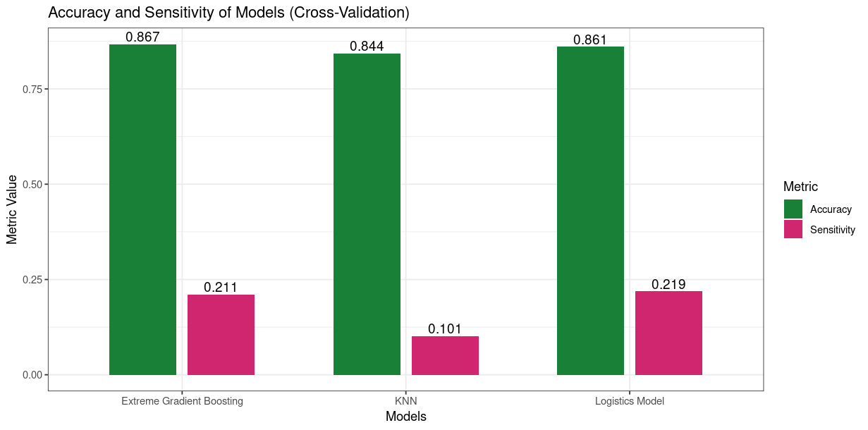
Figure 11: Compare LR, KNN, and XGB

